Introduction
Due to the increasing cases of infections caused by bacteria amongst our populations in our daily environment, we decided to conduct a survey especially in our public areas with a primary aim of identifying the extent of exposure to bacterial infections and the possible remedies to these exposures. We therefore picked random public utility places picking samples and conducting tests for the presence of bacteria.
We conducted a survey to identify airborne, aero sore, bacteria in a closed area of Harold Washington College building. The area that we collected the samples was north east corner of the 11th floor. We identified these bacteria samples by colony characteristics, staining and biochemical test.
Using colony morphology to identify the bacteria characteristics, we observed these bacteria with the intentions of identifying them in different colonies in terms of form, size, color, their surface and different other characteristics. We then keep them in one place to allow them to form visible patches making it easy to conduct tests.
On the staining method, the group will largely resort to gram staining technique where we will prepare slides to stain the specimen with crystal violet through to decolonization and counterstaining to see whether the bacteria cells are either gram positive or negative depending on the resulting counterstain of the primary stains.
The bacteria types that we are likely to find in this exercise is not only restricted to be found here. They are the common types of bacteria that can be found in any common placed especially shared by people including schools, daycare facilities, hospitals and social halls. Therefore the purpose of this lab test is to identify the extent of our exposure to different forms of bacteria in creating awareness and knowledge on how to deal with same in avoiding extensive infections.

Material and Method
- Collect aerosol-associated microbes
First of all, we had labeled the bottom of BHI plate. Then we placed it on 11 floor of the college by open the lid and face up. After two hours, close the lid and kept the plate face down in the incubator at 37 Celsius for two days. After two days, we count the number of colony that shown in BHI plate. We also define shape and color of the colony.
We will transfer our bacteria from BHI plate to the nutrient agar broth by using the burned inoculating loops taking a small amount of bacteria. Spread the bacteria to the nutrient agar broth in one the wavy line. Then take the tube to incubator at 37C for 24 hours. From now on we will use bacteria from this new test tube to examine in the experiment.

- Oxidase test
To examine oxidase test, took bacteria from the slant by using the tip of a sterile cotton swab. Dropped oxidase reagent 1 drop on bacteria and collect the change within 20 second.
- Phenylalanine deaminase test
To examine phenylalanine deaminase, we took some of the bacteria by inoculated from agar test tube that we had prepared to the agar slant in wavy line from bottle to top. Incubated the tube at 37C for 48 hours. Then tested by adding 3 drops of 12% FeCl3 oxidase to the surface of agar slant and carefully determine if a color changed within 5 minutes.
- Monitor salt agar
To examine monitor salt agar, we will inoculate the bacteria to salt agar plate in wavy lines. And another salt agar plate we also inoculate 3 bacteria sources which is Staphylococcus aureus, Staphylococcus epidermidis and Streptococcus pyogenes. Place both plates upside down and put it in incubator at 37C. After 48 hours of incubated identify the bacteria growth and fermentation.
- Blood agar
For blood agar test, we did the same steps as salt agar for both of our bacteria and given bacteria sources. But after we spread the bacteria on blood agar in wavy line, we also stabbed three times on the agar near the line. Place the plate to incubate upside down for 48 hours at 37C. identify the types of hemolysis.
- Gram stain
After we can describe the colony, we prepared slide to do gram stain. We light the Bunsen burner first. We put the slide holder in metal tray and placed clean glass slide over it. Grab the inoculating loops and flamed it until loop is red, wait until it cools down. Used left hand to hold the saline tube. Open and hold the saline tube cap with right pinky finger. Flamed mouth of saline tube 3 times over the outer cone of flame. Insert flamed inoculating loops into the tube to get a saline. Spread loop of saline over the clean slide that we had prepared. Flamed mouth of saline tube. Closed the lid and place it back to the tube holder. Flamed inoculating loops again, wait until it cools down. Use the loop to get small amount of bacteria from the colony that we want to observe and spread it in a round shape over the saline on the glass slide. Flamed the slide 3 times over the outer cone of flame.

After the slide had prepared, we started stain the bacteria. First, we dropped Crystal violet over the spread area, wait for 30 seconds and rinse. Drops Iodine over the same area, also wait for 30 seconds and rinse. Drops Decolorizer over the same area, wait for 5-10 seconds and rinse. Then drops Safranin over the same area again, wait for 30 seconds and rinse. Dry the slide with the Bibulous paper. Observe the slide with microscope at 4X first and the at 100X. Once we done with the gram stain, we will start doing Phenylalanine deaminase and oxidase test.
- Citrate
Inoculate the citrate slant with needle and incubated at 37C for 24 hours. Check if there are any color change.
- Indole
Inoculate and then drop indole reagent. The color will change within 30 second.
- Methyl Red
To examine Methyl Red, we took some of the bacteria by inoculated from agar slant that we had prepared to the test tube. Using Methyl red pH indicator and checked for the color change.
- Voges Proskauer
We inoculated the bacteria from agar to test tube that contain broth. Add 3 drops of Methyl red and read the result immediately. After that drop Voges Proskauer-A for 15 drops and mixed well. And another 5 drops of Voges Proskauer-B and mixed. Shake it for 1 hours and checked on color change every 10 minutes.
- Urea
- MacKonkey
- Phenol Red Glucose
- Phenol Red Lactose
- Gelatin
- Starch
- Catalase
- Lipase
- Coagulase
- Dnase
- Bile Esculin Agar
- Nitrate

Results
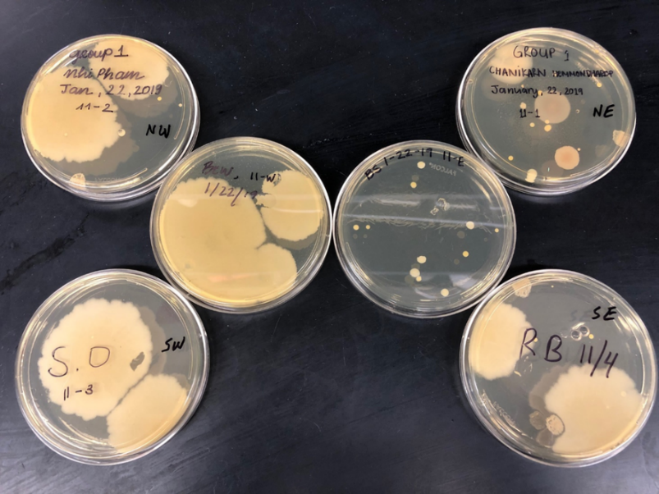
Figure 1. Airborne microbial colonies of the 11th floor at Harold Washington building , the corner of north east for the elevator after incubator for 2 days.

Figure 2. Pictures of different bacteria that already gram stain in purple and pink.
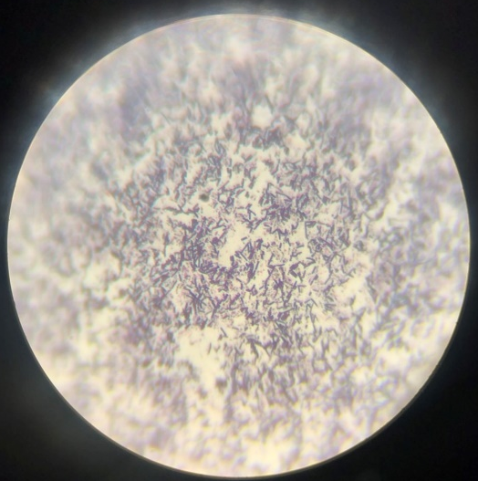
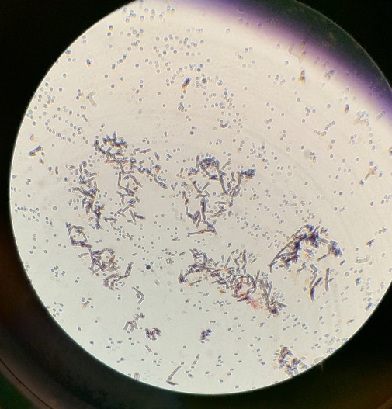
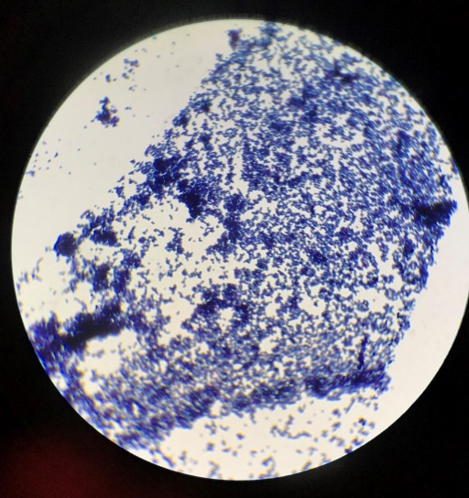

Figure 1 showed that some colonies have the same shape and texture, but some are not. Most of the colony are round, small and have yellow color. After we had done the gram stain most of the result came out purple that showed in figure 2

Figure 3. Gram stain from the slant
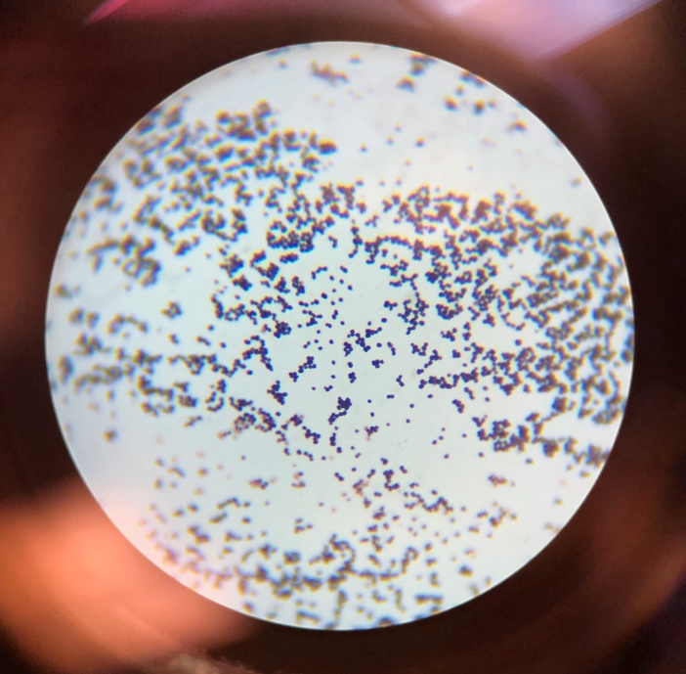

Figure 4. bacteria growth in the nutrient agar broth after incubated for 24 hours.
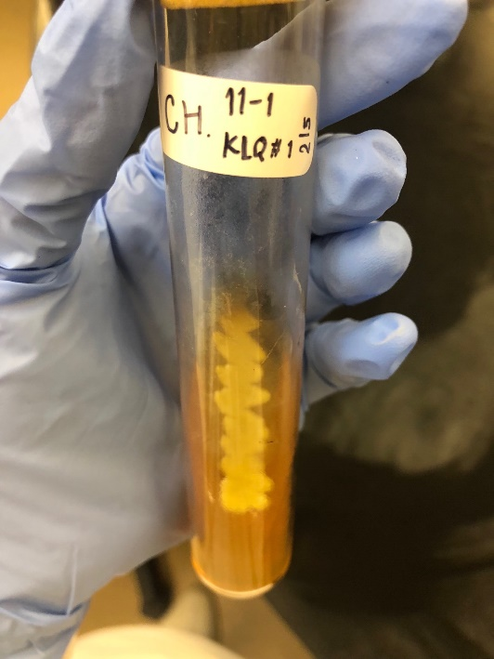

This figure show that our bacteria transfer was success because it have the growth after came out of the incubater.

Figure 5. the phenylalanine deaminase agar before putting into the incubator.
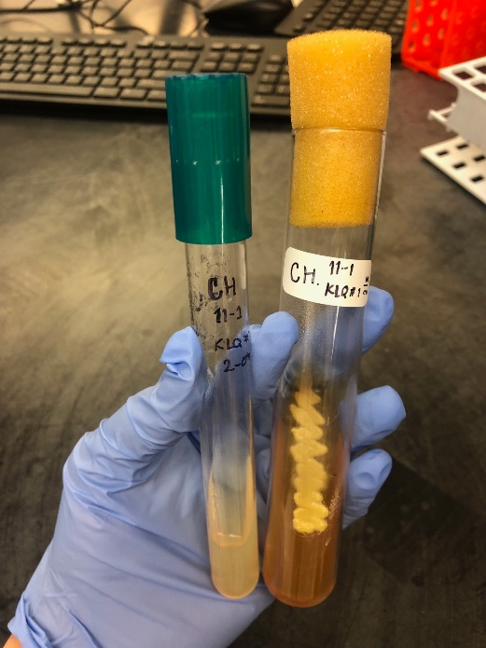

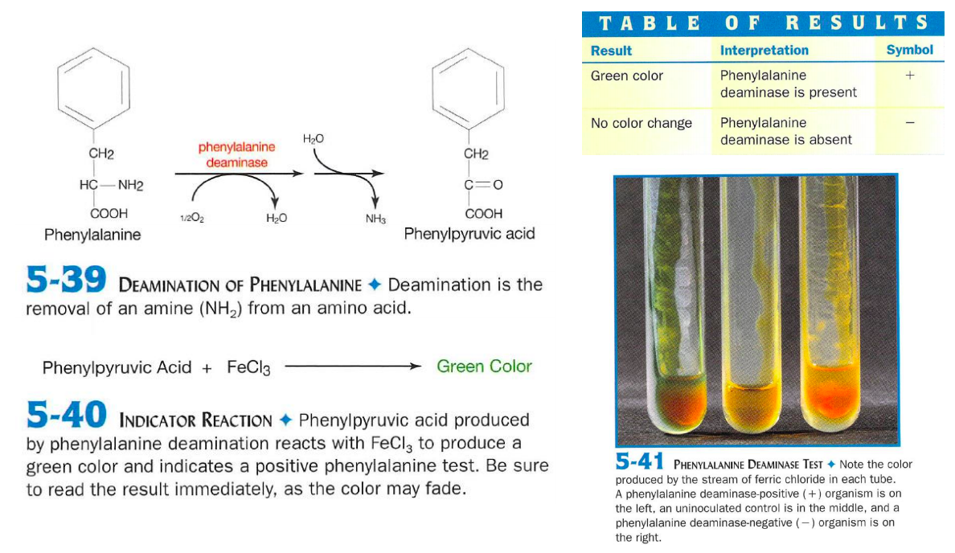
Figure 6. When oxidative deamination occurs within phenylalanine, pyruvic acid reacts with the reagent FeCl3 to produce a green hue. No color change is present without this chemical reaction.

Figure 7. Examine oxidase test If shows a purple color so it is oxidase production and If the color shown the same, so it is an oxidase negative.

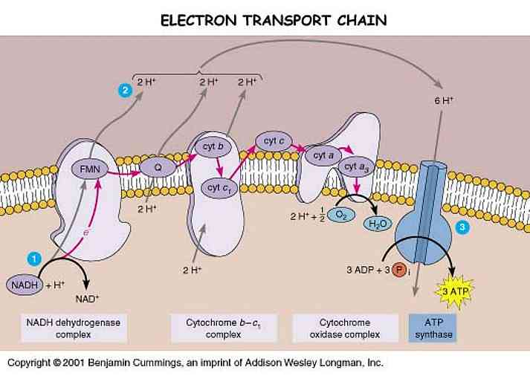
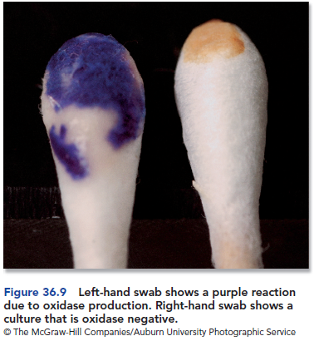

Figure 8. bacteria from building on mannitol salt agar after incubated for 48 hours
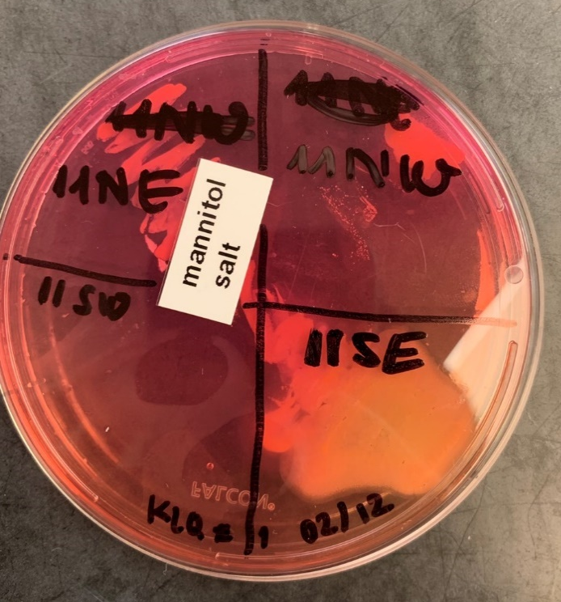

The result from mannitol salt agar came out with red growth but no halo so this bacterium is a Staphylococcus other than S. aureus.
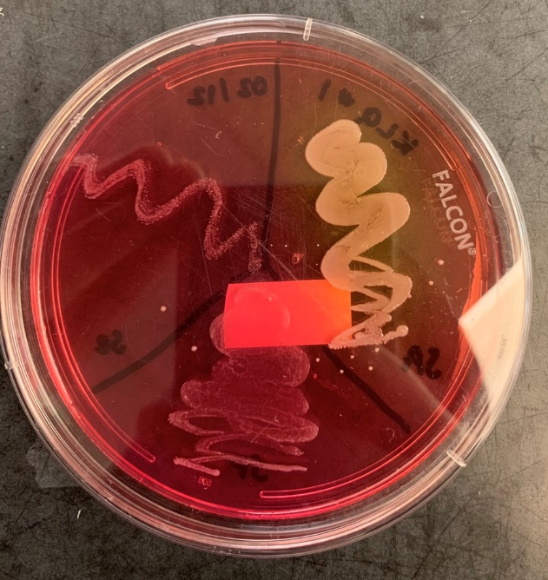
Figure 9. Bacteria sources on mannitol salt agar after incubated for 48 hours
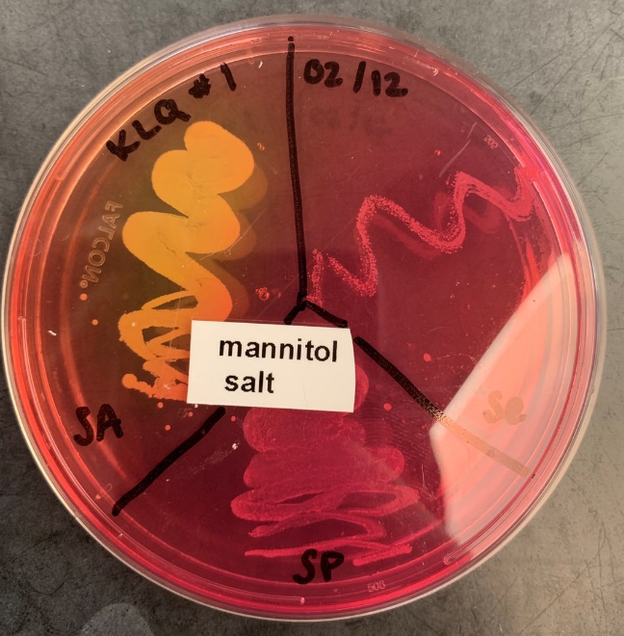

Figure 10. bacteria from building on blood agar after incubated for 48 hours
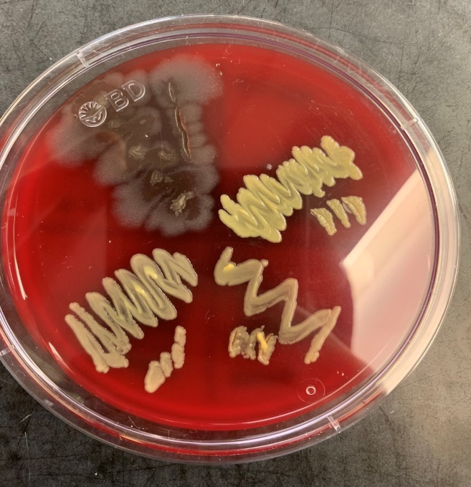
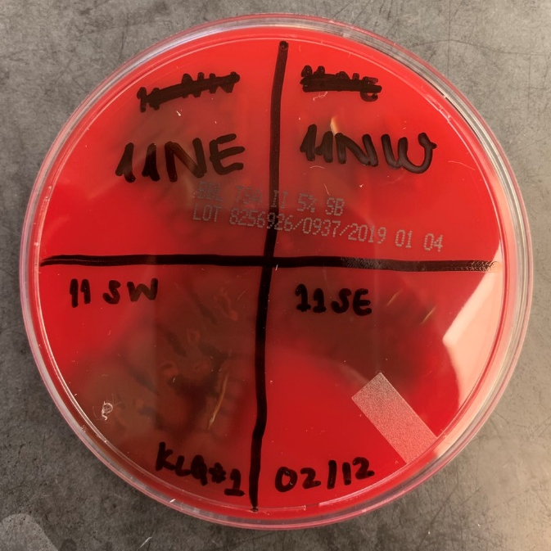

The result from blood agar shown good growth with no change of medium’s color.
Figure 11. Bacteria sources on blood agar after incubated for 48 hours
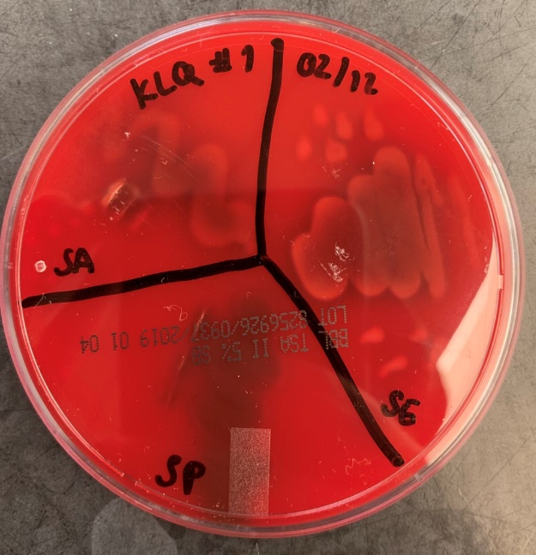
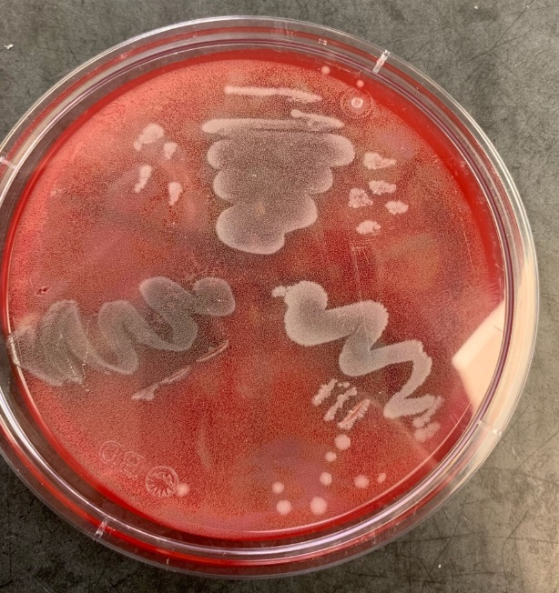

After incubated the BHI plate that collect the airborne from 11th floor of Harold Washington building for 2 days, the colony had formed. The colony that shown in the plate are round, filamentous and rhizoid. After we had done gram stain and looking through the microscope, the gram stain pictures that shown in the result is a stain from different area. So we know that the bacteria in environment have many different type even in the same area. Gram stain the result shown that bacteria we choose to examine is positive staphylococcus. The phenylalanine test came out negative, but oxidase test was positive.
The result of FeCl3 tested was negative because there is no any color change on the agar. However, the oxidase test came out positive because after we had dropped a reagent the tip of cotton swap changed to purple.
The result from mannitol salt agar was red growth but no halo so we can say that this bacterium is a Staphylococcus other than S. aureus. Which is matched with our gram stain result. And the blood agar shown good growth but no any change so the result was negative.

Discussion
The bacteria samples that we collected from the 11th floor of the building had shown many types of colony which mean in our daily environment it has many types of bacteria. The bacteria that I choose to examine was identified by gram stain method. Application of crystal violet to the sample of bacterial culture collected before iodide was added to trap the primary stains in the cells. After the trapping, decolorization was done using ethanol after which we applied safranin for counterstaining. Whereby after decolorization, the bacteria appeared to remain blue, and further application of counterstain, the bacteria remained to be blue affirming that it is gram positive and it is staphylococcus.
In the genus Staphylococci, Staphylococcus aureus and Staphylococcus epidermidis are the major source in the hospital. It can cause skin infections, food poisoning, meningitis, pneumonia, tract infections and can be linked to foreign bodies.
FeCl3 tested for the presence of phenylalanine whereby the samples were dissolved in water and adding drops of ferric chloride solution and its byproducts of phenyl pyruvic acid and ammonia. These byproducts were a result of oxidative deamination. The purpose of this experiment was to determine whether oxidative deamination occurred and if phenyl pyruvic acid and ammonia were produced to aid in bacterial growth of the inoculum.
S. aureus and alignments when viewed under a microscope, large and round yellow colonies were visible. The cells appeared much yellow transparent to further confirm that the bacteria is β-hemolytic. Every culture presented a clear and/or golden yellow color where the bacteria was present. The result can tell that S. aureus produced hemolysins that caused red blood cells to lyse. Typically, S. aureus is not a fatal threat to humans.
S. epidermidis is ɣ-hemolysis coincides with current literature. The colony shown no sign of any change. Since the bacteria do not create hemolysins that threaten to deteriorate the red blood cell walls, then there is no need to fret over hemolytic disease. Even though it can sometimes prove to be a health concern when it is involved in infections acquired in hospitals.
S. pyogenes concluded as ɣ-hemolytic in this experiment. These results conflict with the expected results of β-hemolytic. As seen with S. aureus, S. pyogenes should have produced a clear (not golden yellow) form on the blood agar.

Table 1 biochemical test
Test | Result | Interpretation
Bacteria collection | 17 colonies  4 colors  Round shape  Filamentous shape  Rhizoid shape
Oxidase | No color change | No oxidase
Phenylalanine deaminase | Yellow color | No
Monitor salt agar | Growth no fermentation | Staphylococcus
Blood agar | Growth with green | Alpha
Gram stain | Purple color | Positive Staphylococci
Citrate | No color change | Yes
Indole | Yellow color | No
Methyl Red | Yellow | No
Voges Proskauer | Yellow | No
Urea | Yellow | No
MacKonkey | Growth no pink | No
Phenol Red Glucose | Red | No growth
Phenol Red Lactose | Red | Growth
Gelatin | Yellow | Yes
Starch | Colorless | No
Catalase | Bubble | Yes
Lipase | Blue | Yes
Coagulase | Colorless | No
Dnase | Colorless | No
Bile Esculin Agar | Colorless | No
Nitrate | Colorless | No ZINC

Table 2 Bacteria identification
Group | 1st bacteria | Similarity percentage | Probability percentage
Campy and Helicobacter | Unknown taxon | - | -
Enterobacteriaceae | No matching | - | -
Non-fermenters | Acinetobacter haemolyticus | 88.3 | 20.79
Neisseriales | No matching | - | -
Pasteurellaceae | No matching | - | -
Vibrio and Aeromonas | No matching | - | -
Bacillus and Paenibacillus | Lysinibacillus fusiformis | 97.1 | 20.16
Clostridium | Clostridium subterminale | 83.8 | 0.34
Corynebacterium | Pseudarthrobacter equi | 90 | 12
Lactobacillus | No matching | - | -
Listeriaceae | Erysipelothrix inopinata | 82.7 | 3.15
Staphylococcus | Unknown taxon | - | -
Streptococcus | Unknown taxon | - | -

References

(2019). Retrieved from http://www.health.state.mn.us/divs/idepc/diseases/staph/basics.html
(2019). Retrieved from https://catalog.hardydiagnostics.com/cp_prod/Content/hugo/PhenylalanineAgar.htm
(2019). Retrieved from https://www.jfmed.uniba.sk/fileadmin/jlf/Pracoviska/ustav-mikrobiologie-a-imunologie/VLa/STAPHYLOCOCCI.pdf
B, D. (2019). Optimum use of selective plated media in primary processing of respiratory tract specimens from patients with cystic fibrosis. - PubMed - NCBI. Retrieved from https://www.ncbi.nlm.nih.gov/pubmed/?term=Streptococci+mannitol+salt+agar
Buchanan R, e. (2019). Performance of Gram Stains and 3 Culture Methods in the Analysis of Peritoneal Dialysis Fluid. - PubMed - NCBI. Retrieved from https://www.ncbi.nlm.nih.gov/pubmed/30858289
Buxton, R. (2019). ASMscience | Blood Agar Plates and Hemolysis Protocols. Retrieved from http://www.asmscience.org/content/education/protocol/protocol.2885
Caroline Mohr O'Hara, J. (2019). Classification, Identification, and Clinical Significance of Proteus, Providencia, and Morganella. Retrieved from https://www.ncbi.nlm.nih.gov/pmc/articles/PMC88947/
Enterobacter aerogenes - microbewiki. (2019). Retrieved from https://microbewiki.kenyon.edu/index.php/Enterobacter_aerogenes
Koivisto AJ, e. (2019). Source specific exposure and risk assessment for indoor aerosols. - PubMed - NCBI. Retrieved from htts://www.ncbi.nlm.nih.gov/pubmed/30851679
LOWBURY EJ, e. (2019). A NEW SELECTIVE BLOOD AGAR MEDIUM FOR STREPTOCOCCUS PYOGENES AND OTHER HAEMOLYTIC STREPTOCOCCI. - PubMed - NCBI. Retrieved from https://www.ncbi.nlm.nih.gov/pubmed/14159449
Mendes RE, e. (2019). Distribution of main Gram-positive pathogens causing bloodstream infections in United States and European hospitals during the SENTRY Antimicrobial... - PubMed - NCBI. Retrieved from https://www.ncbi.nlm.nih.gov/pubmed/30843778
Phenylalanine Deaminase Test : Principle, Procedure, Results and Uses -. (2019). Retrieved from https://microbeonline.com/phenylalanine-deaminase-test-principle-procedure-results-uses/
R, C. (2019). Gram staining. - PubMed - NCBI. Retrieved from https://www.ncbi.nlm.nih.gov/pubmed/18770544
R, S. (2019). Group B Streptococci in Pregnancy: New Perspectives for Old Challenges. - PubMed - NCBI. Retrieved from https://www.ncbi.nlm.nih.gov/pubmed/30843310
Tortora, G., Case, C. and Funke, B. (2016). Microbiology: An Introduction. 12th ed. Pearson, p.310-311.
Staphylococcus aureus colony morphology and microscopic appearance, basic characteristic and tests for identification of S.aureus bacteria. Images of Staphylococcus aureus. Antibiotic treatment of staphylococcal infections. (2019). Retrieved from https://www.microbiologyinpictures.com/staphylococcus%20aureus.html
Staphylococcus epidermidis on blood agar. Colonies of S.epidermidis on blood agar. (2019). Retrieved from http://www.bacteriainphotos.com/staphylococcus_epidermidis_on_blood_agar.html
Streptococci, groups A, B, and D. Enterococcus faecalis. (2019). Retrieved from http://www.microbiologybook.org/fox/streptococci.htm
Streptococcus pyogenes colonies on blood agar. (2019). Retrieved from http://www.bacteriainphotos.com/Streptococcus%20pyogenes.html
Wilhelm MJ, e. (2019). Gram's Stain Does Not Cross the Bacterial Cytoplasmic Membrane. - PubMed - NCBI. Retrieved from https://www.ncbi.nlm.nih.gov/pubmed/25879387
www.cdc.gov/ncidod/dhqp/gl_isolation.html.
. Koneman, E.W., et al. Color Atlas and Textbook of Diagnostic Microbiology, J.B. Lippincott Company, Philadelphia, PA.

. Tille, P., et al. Bailey and Scott's Diagnostic Microbiology, C.V. Mosby Company, St. Louis, MO.

Anderson, N.L., et al. Cumitech 3B; Quality Systems in the Clinical Microbiology Laboratory, Coordinating ed., A.S. Weissfel. American Society for Microbiology, Washington, D.C.
. Jorgensen., et al. Manual of Clinical Microbiology, American Society for Microbiology, Washington, D.C.
Isenberg, H.D. Clinical Microbiology Procedures Handbook, Vol. I, II & III. American Society for Microbiology, Washington, D.C.
Buttiaux, et al. 1954. Ann. Inst. Pasteur; 87:375-386
Ewing, et al. 1957. Pub Hlth Lab.; 15:153.
Hendriksen. 1950. J. Bacteriol.; 60:225.
Rasigade JP, Vandenesch F. Staphylococcus aureus: a pathogen with still unresolved issues. Infect. Genet. Evol. 2014 Jan;21:510-4
Centers for Disease Control and Prevention (CDC). Outbreaks of community-associated methicillin-resistant Staphylococcus aureus skin infections--Los Angeles County, California, 2002-2003. MMWR Morb. Mortal. Wkly. Rep. 2003 Feb 07;52(5):88
Le KY, Otto M. Quorum-sensing regulation in staphylococci-an overview. Front Microbiol. 2015;6:1174. [PMC free article] [PubMed]
Musser JM, Schlievert PM, Chow AW, Ewan P, Kreiswirth BN, Rosdahl VT, Naidu AS, Witte W, Selander RK. A single clone of Staphylococcus aureus causes the majority of cases of toxic shock syndrome. Proc. Natl. Acad. Sci. U.S.A. 1990 Jan; 87(1):225-9. [PMC free article] [PubMed]
Foster TJ. Immune evasion by staphylococci. Nat. Rev. Microbiol. 2005 Dec;3(12):948-58. [PubMed]
DeLeo FR, Diep BA, Otto M. Host defense and pathogenesis in Staphylococcus aureus infections. Infect. Dis. Clin. North Am. 2009 Mar;23(1):17-34. [PMC free article] [PubMed]
Salgado-Pabón W, Breshears L, Spaulding AR, Merriman JA, Stach CS, Horswill AR, Peterson ML, Schlievert PM. Superantigens are critical for Staphylococcus aureus Infective endocarditis, sepsis, and acute kidney injury. MBio. 2013 Aug 20;4(4) [PMC free article] [PubMed]
Lowy FD. Staphylococcus aureus infections. N. Engl. J. Med. 1998 Aug 20;339(8):520-32. [PubMed]
Tong SY, Davis JS, Eichenberger E, Holland TL, Fowler VG. Staphylococcus aureus infections: epidemiology, pathophysiology, clinical manifestations, and management. Clin. Microbiol. Rev. 2015 Jul;28(3):603-61. [PMC free article] [PubMed]
Boucher HW, Corey GR. Epidemiology of methicillin-resistant Staphylococcus aureus. Clin. Infect. Dis. 2008 Jun 01;46 Suppl 5:S344-9. [PubMed]
Chambers HF. Community-associated MRSA--resistance and virulence converge. N. Engl. J. Med. 2005 Apr 07;352(14):1485-7. [PubMed]

